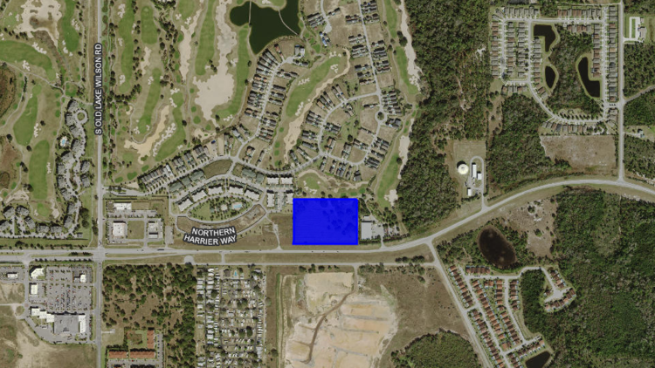
A developer in interested in building apartments on this 6.9-acre tract on the Osceola-Polk Line Road, just outside of Reunion. (Osceola County Property Appraiser)
Laura KinslerContact Reporter
GrowthSpotter

A Brazilian real estate investor will pursue a Commercial Tourist rezoning for 6.9 acres on Osceola Polk Line Road in Four Corners, his broker told GrowthSpotterFriday.
Sean Fullerton said his client, Haroldo de Barros, has a contract to buy the property, which is just outside of the Reunion Resort. He attended a pre-application meeting June 2 on de Barros' behalf with Osceola County planners to discuss a proposal to build a 120-unit apartment complex there.
County staff advised him to seek the Commercial Tourist land use and rezoning, which would allow for the greatest flexibility. Fullerton said as they move forward with the permitting process, the highest and best use will reveal itself.
"In this case, I can't tell you they're going to build 120 apartments," Fullerton said. "I have discussed that property with another potential buyer who is looking for a site to do a branded hotel."
Fullerton said de Barros, through his affiliate Danpol Development, currently owns two other parcels in the Four Corners market that are fully entitled.
"They haven't built on either of those properties," he said. "When the market gets real active, like it is now, investors sometimes will tie up a piece a property and wait for a buyer. I see that happening in this case, it's certainly one of the options."

